# 

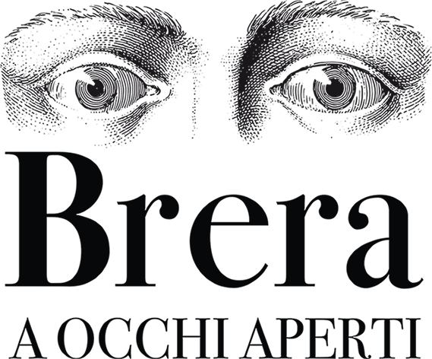

# Overview

The document provides a detailed guide on game dynamics, user interactions, and integration with the physical experience in the gallery. Through a clear exposition of game mechanics and interactive features, the GDD unifies the project vision, facilitating the work of developers and designers to ensure an engaging app centered around the visitor.

# External links

## [Team](https://docs.google.com/spreadsheets/u/0/d/18lO-1el5R-KtGudTj-XQAgODXawRCsYqRpQFyqqfYS8/edit)

## [Project Management](https://docs.google.com/document/d/1pvidVdDjKh2bkZ_LnIOw99VXGaNfz898TLwIufQ5Z_k/edit?usp=drive_link)

## [TDD](https://docs.google.com/document/u/0/d/1SF9txNtm4E2bL6CRLWBqhJcccmKGzYtxsEmCLYjkDFo/edit)

## [Art Guidelines](https://docs.google.com/document/u/0/d/1NWryRUMatZkjNkeQvAfiqKxjA-nPbLEJGjhcy7ZjC8o/edit)

## [Roadmap](https://docs.google.com/spreadsheets/u/0/d/1Ohlc7BWeWkpMMtLpSfQ_xZO9dnzvNixZQ52Edp2Prek/edit)

**Table of Content**

**Overview 2**

**External links 2**

**● Team 2**

**● Project Management 2**

**● TDD 2**

**● Art Guidelines 2**

**● Roadmap 2**

**1.0 Introduction 5**

**2.0 Context: Pinacoteca di Brera 5**

**3.0 Team/App Goals 5**

**4.0 Key Features 6**

**4.1 Interactive Virtual Tour 6**

**4.2 Paintings Puzzles 6**

**4.3 Insights/Learn more 6**

**4.4 AR Integration 6**

**4.5 Social-Network Layout 7**

**4.6 Dynamic Lighting 7**

**4.7 Dynamic SFX 7**

**5.0 Art Style/Art Guidelines 8**

**5.1 2D Art 8**

**5.1.1 2D References 8**

**5.2 3D Art 8**

**5.2.1 3D References 8**

**7.0 Scope 8**

**8.0 Integration with Brera Art Gallery 9**

**8.1 QR Codes/Paintings Photos & New Areas 9**

**8.2 Insights & Quiz 9**

**8.3 Pinacoteca Map 9**

**1.0 User Research 10**

**1.1 Research Methods 10**

**1.2 Research Goals 10**

**1.3 Research Results 11**

**1.3.1 Proto-Personas 11**

**1.3.2 Users Behaviour 11**

**2.0 Target Audience 12**

**2.1 Platforms: 12**

**2.1.1 Mobile 12**

**3.0 User Journey 12**

**3.1 User Flow 12**

**1.0 Icons & Background Style 13**

**2.0 Wireframes 13**

**2.1 Lo-fi Wireframe 13**

**2.2 Hi-Fi Wireframe 13**

**3.0 Figma Prototype 13**

**3.1 Prototype Goals 13**

**3.2 Prototype Priorities 13**

**1.0 Input System 14**

**6.3 Hold 16**

**Pc: Cursor & Left-Button (Optional) 16**

**2.0 Movement System 17**

**2.1 Visual feedback 18**

2.2 Camera 18

2.2.1 Camera Type 18

**2.2.2 Camera zoom 18**

**3.0 Interactions 19**

**3.1 Interaction window reference: Starfield 19**

**4.0 Dialogue System 20**

**5.0 Inventory System 21**

**6.0 Feedback System (Audio/Video) 22**

**7.0 Cloud Saves 23**

**7.1 Online Mode 23**

**7.2 Offline Mode 23**

**8.0 Level Design (LDD) 24**

**8.1 Interactions 24**

**8.2 Puzzle Elements 24**

**8.2.1 List 24**

**8.2.2 User Engagement 24**

**8.3 Scope 24**

**9.0 Localization (Table) 25**

**9.1 Languages 25**

**● Italian (Main) 25**

**● English 25**

**● German 25**

**● Portuguese 25**

**● French 25**

**9.2 Day/Night System 25**

**10.0 Quality Assurance (QA) 26**

**10.1 Playtest Roadmap 26**

**10.2 Bug-reports 26**

**10.2.1 QA Documentation Layout: 26**

Game Concept

# 1.0 Introduction

The Wunderkammer team will have to develop a gamified application for the museum 'Pinacoteca di Brera' in Milan for a target group between 20 and 35 years old and art lovers.

# 2.0 Context: Pinacoteca di Brera

The Pinacoteca di Brera, situated in Milan, is a prestigious art gallery founded in 1809 as part of the Brera cultural complex. It showcases masterpieces by renowned artists such as Piero della Francesca, Caravaggio, Raphael, and Mantegna, offering visitors an immersive experience in the evolution of Italian art. The unique atmosphere is enhanced by the architecture of the complex, creating a space that highlights the exhibited artworks. A landmark for art enthusiasts, students, and visitors, it is a key institution for those seeking to delve into Italy's rich artistic history.

# 3.0 Team/App Goals

The main purpose of the app is to recreate a virtual museum experience in first person by taking users inside a virtual version accompanied by puzzle games and useful functions for those who love art and museums.

The app should encourage users to engage with the actual museum through various features. The team will subsequently conduct User Experience and User Research studies, delving into the User Journey of the selected target audience.

# 4.0 Key Features

## 4.1 Interactive Virtual Tour

Utilizing controls similar to those found in common exploration and tour apps, such as Google Maps, users will be able to easily move between the various rooms of the museum with a first-person perspective.

## 4.2 Paintings Puzzles

Within the application, users will engage with puzzles designed to prompt interactions with the paintings and their subjects.

## 4.3 Insights/Learn more

An additional function of the application is to delve into the topics and history of the paintings in the Brera Museum catalog.

## 4.4 AR Integration

By scanning QR codes and photos of paintings in the actual museum, users will be able to unlock new areas and insights within the application.

## 

## 4.5 Social-Network Layout

With a recognisable structure and icons, the app will be easy to read and intuitive for all users.

## 4.6 Dynamic Lighting

To recreate an environment similar to that of the museum and as immersive as possible, the team has decided to implement a dynamic natural/ambient lighting system based on the time and weather conditions of the city of Milan.

## 4.7 Dynamic SFX

Directly linked to the dynamic lighting system, an audio system will be implemented that will change based on the weather conditions (e.g., rain, ...).

# 5.0 Art Style/[Art Guidelines](https://docs.google.com/document/u/0/d/1NWryRUMatZkjNkeQvAfiqKxjA-nPbLEJGjhcy7ZjC8o/edit)

The app aims to create a realistic and immersive environment with a focus on paintings.

The graphics will be semi-realistic/realistic, featuring 3D frames for the paintings and realistic 2D images of the original artworks. Special attention will be given to interactive paintings during puzzles. Additionally, 2D elements like menus and UI will be included, with icon styles balancing readability for casual users and conveying a museum-like elegance.

## 5.1 2D Art

## 5.1.1 2D References

## 5.2 3D Art

## 5.2.1 3D References

# 7.0 Scope

The application must permit users to access it periodically and should be regularly updated to reflect real-time changes occurring in the museum, such as the addition of new paintings or the removal of existing ones.

The application should be intuitive and easily understandable, even for individuals not accustomed to video games or similar interfaces.

# 8.0 Integration with Brera Art Gallery

## 8.1 QR Codes/Paintings Photos & New Areas

Some areas of the virtual museum can be added through the scanning of specific QR codes placed in certain points and/or areas of the real museum. The scanning of these codes will be possible through a dedicated screen in the app. Once a code is scanned, a new area of the virtual museum is automatically unlocked, featuring new paintings and dedicated activities.

## 8.2 Insights & Quiz

The app will feature a section dedicated to in-depth insights and quizzes about artworks, artists, and the museum's history, allowing users to delve deeper into styles, artists, and historical/artistic periods.

## 8.3 Pinacoteca Map

The app will feature a map section.

It will be updated by unlocking new areas and can be used by users to discover where the paintings they are looking for are located, even in the real museum. It will be updated with each movement of the artworks.

User Experience

# 1.0 User Research

## 1.1 Research Methods

* Analysis through a Google Form distributed via social networks and other platforms (Reddit, etc.).
* Observations of user behavior in museum settings
* Research and analysis through statistical websites such as ISTAT and similar ones for other selected countries.

## 1.2 Research Goals

* Better understanding the Target Audience sought by the client
* Analyze economic data of selected target countries to better assess potential internal costs of the app
* Understanding the behavior of museum users
* Ensure an ideal and useful experience within our app.

## 

## 1.3 Research Results

The research enabled the team to create 4 distinct profiles of Proto-Personas useful for understanding and studying the behavior of individuals aged between 20 and 35 during museum visits.

The team also disseminated a form through social media, forums, and private contacts with the aim of obtaining responses from as many people as possible.

Successively, we studied the received responses to synthesize and write a summary of real experiences based on those answers.

### 1.3.1 Proto-Personas

* [**Profile 1**](https://docs.google.com/presentation/u/1/d/1UgaNljSxolmP6UVdYkr2q3iG58xXfnTbTumO9Q6IWDU/edit)
* [**Profile 2**](https://docs.google.com/presentation/u/1/d/1UgaNljSxolmP6UVdYkr2q3iG58xXfnTbTumO9Q6IWDU/edit)
* [**Profile 3**](https://docs.google.com/presentation/u/1/d/1UgaNljSxolmP6UVdYkr2q3iG58xXfnTbTumO9Q6IWDU/edit)
* [**Profile 4**](https://docs.google.com/presentation/u/1/d/1UgaNljSxolmP6UVdYkr2q3iG58xXfnTbTumO9Q6IWDU/edit)

# 

# 2.0 Target Audience

## 2.1 Platforms:

To ensure accessibility for as many users as possible, the team has considered as target devices all those with features similar to or superior to the iPhone X. Since it is indeed a high-performing Apple model from a few years ago, it has been taken into consideration and compared to other Apple models not only in terms of price but also in terms of performance.

### 2.1.1 Mobile

* Samsung Galaxy S21 Ultra
* Google Pixel 6 Pro
* OnePlus 9 Pro
* Xiaomi Mi 11 Ultra
* Sony Xperia 1 III
* Asus ROG Phone 6 Pro
* =>iPhone X

# 3.0 User Journey

## 

## 

User Interface

# 

[**Flowcharts**](https://drive.google.com/drive/folders/1KajX0k0WSeuFtdxrluaFiUBoz8QjHhyB?usp=drive_link)

# 1.0 Wireframes

## 1.1 Lo-fi Wireframe

## 1.2 Hi-Fi Wireframe

## 1.3 Icons & Background

# 2.0 Figma Prototype

## 2.1 Prototype Goals

## 2.2 Prototype Priorities

**Development**

# 1.0 Input System

**1.1 Click**

## 

Action consisting of rapidly pressing and releasing a point on the screen.

* **Mobile:** Finger/fingers of the hand
* **Pc:** Cursor & Left-click mouse (**Optional**)

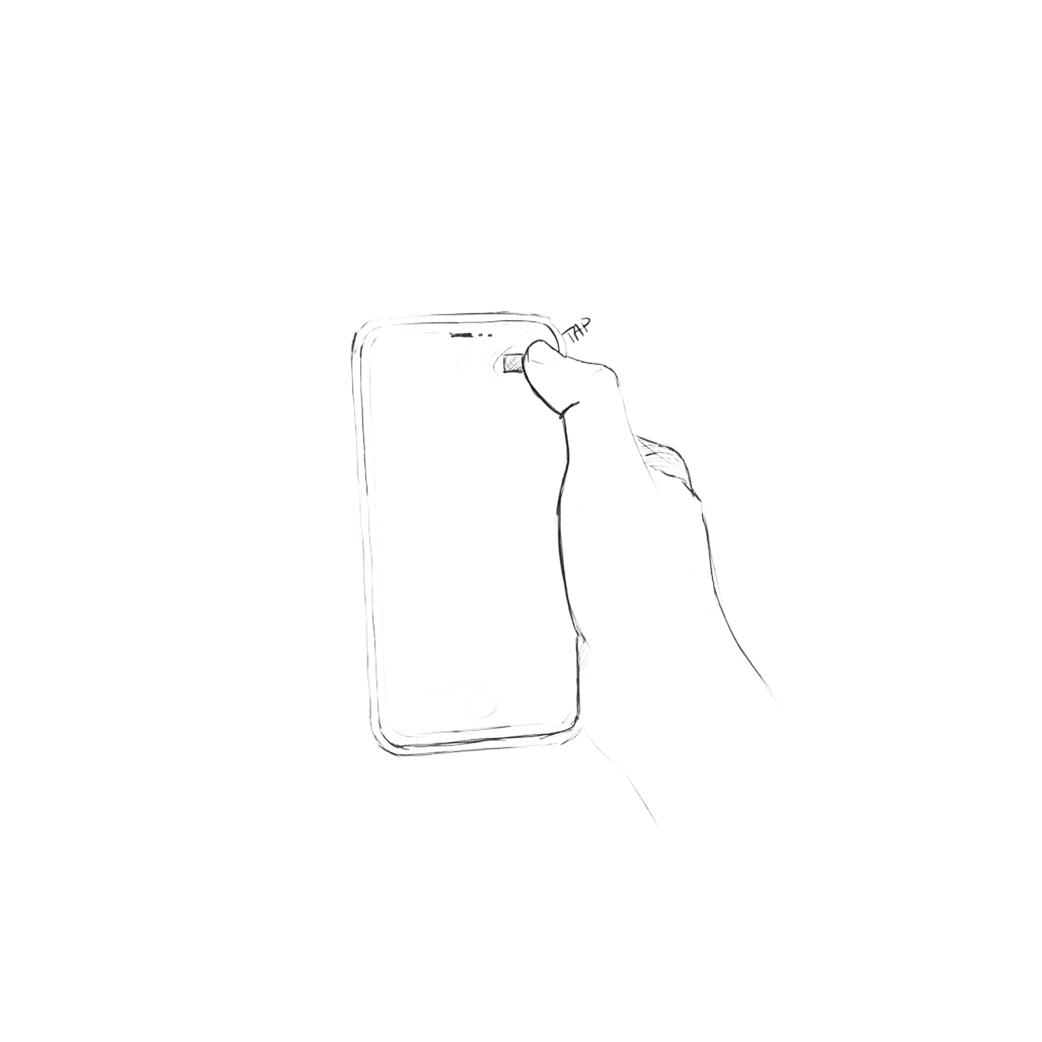

**1.2 Drag**

Action of dragging something while holding down

* **Mobile:** Finger/fingers of the hand
* **Pc:** Cursor & Left-Button
* **Drag Speed:** The camera movement speed is not equivalent to the finger on the screen; instead, it reaches the target specified by the input with a slight delay compared to it.

# 

## 6.3 Hold

Something while being pressed

* **Mobile:** Finger/fingers of the hand

# Pc: Cursor & Left-Button (Optional)

# 

# 

# 2.0 Exploration System

**Nodes:** Predefined coordinates/points for movement within the virtual tour of the app.

**Path:** The route between one node and another. The team can modify these routes to avoid potential collisions with obstacles during automatic movement between nodes.

The user primarily interacts with the user interface, which includes visual controls such as directional arrows and other interactive icons that serve various purposes. The arrows are positioned within the environment, but remain recognisable because they are designed to appear overlaid from the 3D style.

Movement is performed between **nodes (By clicking on their buttons)** that must be strategically positioned by the team to allow users to view rooms and artworks from a better perspective. When an arrow is clicked to move towards a specific room or corridor, a quick transition occurs in which the user sees the camera/character move rapidly in the indicated direction.

## 2.1 Nodes Transitions:

To be able to edit each individual move, each node will have a customizable transition accessible from the inspector. These transitions will enable the management of the camera's direction side.

The basic transition between a node and others is always of the "Instant" type. However, if a user clicks on a node that has been assigned a different transition, it will affect the interaction with the node to which it is assigned.

**For example**: if the default interaction is "**Linear**" but node B is assigned the "**Instant**" transition, the transition from point A or C to B will always be of the "**Instant**" type.

**The transitions are:**

* **Instant:** Through this transition, the user is instantly transported to the selected node. The user's position is then adjusted to match that of the chosen node, and the camera rotation is aligned with the predefined values of the selected node.
* **Linear:** Through this transition, the user moves at a constant speed from their current position to the selected point. During the transition, the rotation of the player's camera is aligned with that of the selected node (default value).
* **FOV:** Through this transition, the user moves with a "**Linear**" motion, but during the movement, the Field of View (FOV) is also adjusted. The FOV modification occurs instantly upon interacting with the button associated with the desired node. The FOV is adjusted to a predetermined value set in the inspector and returns to the previous value once the destination is reached.

**Note:** During the transition, the user cannot move their view or interact with other elements of the UI.

**Main Reference:** Google Maps

## 

## 

## **2.1 Visual feedback**

During movement, the virtual environment responds visually to indicate a change in position. For example, the map can scroll in a specific direction or rotate to follow the user's movement.

## 2.2 Camera

When interacting with a painting in the app and selecting it, the camera will zoom in to show the artwork up close with a well-studied perspective. Therefore, it will be necessary to position a node for each painting to enable this type of interaction.

### 2.2.1 Camera Type

## 

Perspective Camera

### 2.2.2 Camera zoom

## 

Users can zoom **in or out** to obtain a more detailed overview or a wider view. This can be achieved through zoom in/out commands or gestures such as pinching on a touch screen.

**Note:** This approach allows users to explore the virtual environment intuitively, as they would in reality, providing a smooth and immersive navigation experience.

# 

# 3.0 Interactions

Within the application, it will be possible to interact with the works inside the Brera museum in many different ways. Users will be allowed to access various pieces of information regarding the artworks in different rooms to delve into their history and that of the artists. Furthermore, on some screens, it will be possible to find information about the historical period and key moments of various epochs.

When the user has the paintings in their field of view, they will have the opportunity to interact with some buttons positioned next to them. By interacting with these "Information" buttons, a window will open (similar to the one in the related image) containing general information and/or keywords related to the selected artwork.

## 3.1 Interaction window reference: Starfield

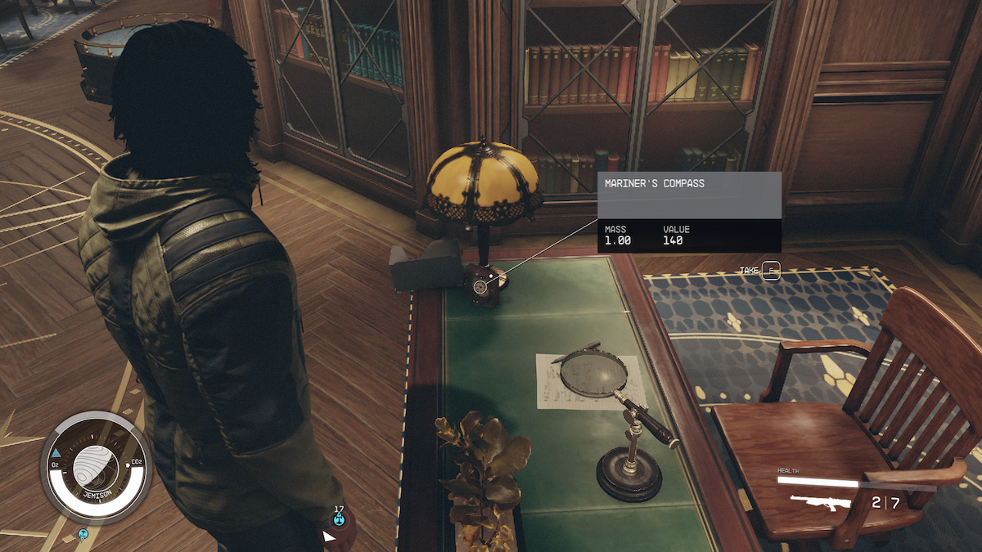

**Note:** Through this system, users will have the opportunity to conveniently view the most relevant information without it overlapping.

# 

## 3.2 Interactions with pieces of art

## 

## 

# 4.0 Dialogue System

To implement guides and one of the puzzles in the app, the implementation of a Dialogue System inspired by those used in visual novels will be necessary. Specifically, text boxes for dialogue, boxes for the name of the speaking character, and boxes and buttons for multiple responses during dialogues will be required.

**Visual Novel style Dialogue System**

**Main Ref:**

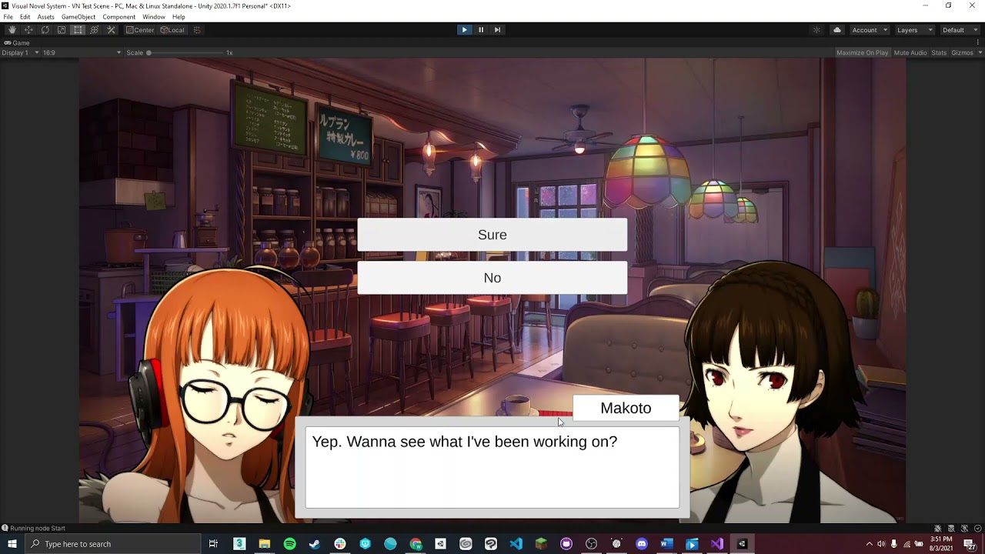

## 4.1 How it works:

When a dialogue is initiated, one speaker at a time is displayed along with their artwork (ref: Hades), accompanied by a text box positioned just above the character's name who is speaking.

The text appears instantly, and with each change in the dialogue line, a brief sound (similar to a chuckle) is played. When a character has finished all the intended dialogue lines, all the elements related to that character are deactivated and are no longer visible.

Subsequently, the elements for the next phase of the dialogue are activated, such as:

Buttons for player responses

**Max number of choices:** 4

Next character in the dialogue and related elements (behaves like the previous character).

# 

## 4.2 Profiles/Variants

# 

In one of the puzzles presented in the virtual tour the user will have to work out through multiple choice dialogues which of 2 characters is lying about his or her identity.

In order to guarantee gameplay variety and not to repeat the same dialogues, it will be necessary to allow the designers to work on several profiles of the same character.

Once completed it will therefore be necessary to randomize the character profiles each time the app is started, so that the answers will be different, the profiles being selected randomly.

## 4.3 Dialogues

The user will have a maximum of responses to choose from during dialogues and can skip those of the npcs by simply clicking on the screen.

Clicking once skips 1 line of dialogue.

# 5.0 Quiz System

From the quiz menu, you can interact with the following buttons:

**Start Quiz:** When clicked, initiate the daily quiz.

**Next Quiz:** A counter indicating the time to wait before being able to repeat the quiz.

The counter begins once the quiz is completed for the first time in the day and becomes available again after 24 hours.

If the user clicks on "**Start Quiz**," they will be presented with questions about the works in the museum, the authors, and art in general.

(This utilizes the dialogue system to pose questions and outlines how the player can respond.)

# 

# 6.0 Inventory System

# 

Some information related to the paintings linked to the game puzzles will be hidden until their completion. To manage the unlocking of these texts, it will be necessary to implement an Inventory System that allows designers to control the contents to be hidden or activated as rewards upon completing the puzzles through **checkboxes and/or flags** in the inspector.

## 6.1 Unlockable Rewards

### 6.1.1 Insights

### 6.1.2 Statue Pieces

### 6.1.3 Art Points

# 7.0 Shop

# 

# 8.0 Feedback (Audio/Video)

# 

# 

# 9.0 Cloud Saves

To keep the museum areas and zones unlocked through the scanning of paintings updated, it will be necessary to implement a saving system and two startup modes, online and offline.

**Saves:** Data related to the user account and unlocked areas will be saved through periodic automatic saves. Additionally, progress related to the tackled puzzles will be stored.

## 9.1 Online Mode

Users can launch the app in online mode to take advantage of secondary services such as purchasing tickets for museum visits, news about events, etc.

## 9.2 Offline Mode

This mode allows starting the app with secondary online functions disabled.

# 

# 10.0 Level Design ([LDD](https://docs.google.com/document/u/0/d/1nYeaWrOSN2TisZezQizkO_46V9ND89pO5j6kZwuwj3M/edit))

[**Metrics**](https://docs.google.com/spreadsheets/u/0/d/1udRj-QyI_8EGk7IY0dF9ofNXQzMcv7-yH5VGXDcyg84/edit)

## 10.1 Interactions

## 

## 

## 10.2 Puzzle Elements

## 10.2.1 List

## 10.2.2 User Engagement

## 10.3 Scope

# 

# 11.0 Localization ([Table](https://docs.google.com/spreadsheets/d/1R9xRFQhPCK_x3uA2XjcvQuS4JeXCF9b4OP6L-aUW89w/edit#gid=0))

# 

## 11.1 Languages

### Italian (Main)

### English

### German

### Portuguese

### French

## 11.2 Day/Night System

To enhance the sense of immersion within the application, the team has decided to implement a real-time localization system using a [**Weather API**](https://rapidapi.com/weatherapi/api/weatherapi-com). This system will dynamically manage weather conditions and lighting with an automatic update every hour. Data related to location (country), weather, and time will be utilized.

# 

# 

# 12.0 Quality Assurance (QA)

[**Project Management**](https://docs.google.com/document/u/0/d/1pvidVdDjKh2bkZ_LnIOw99VXGaNfz898TLwIufQ5Z_k/edit)

## 12.1 Playtest [Roadmap](https://docs.google.com/spreadsheets/u/0/d/1Ohlc7BWeWkpMMtLpSfQ_xZO9dnzvNixZQ52Edp2Prek/edit)

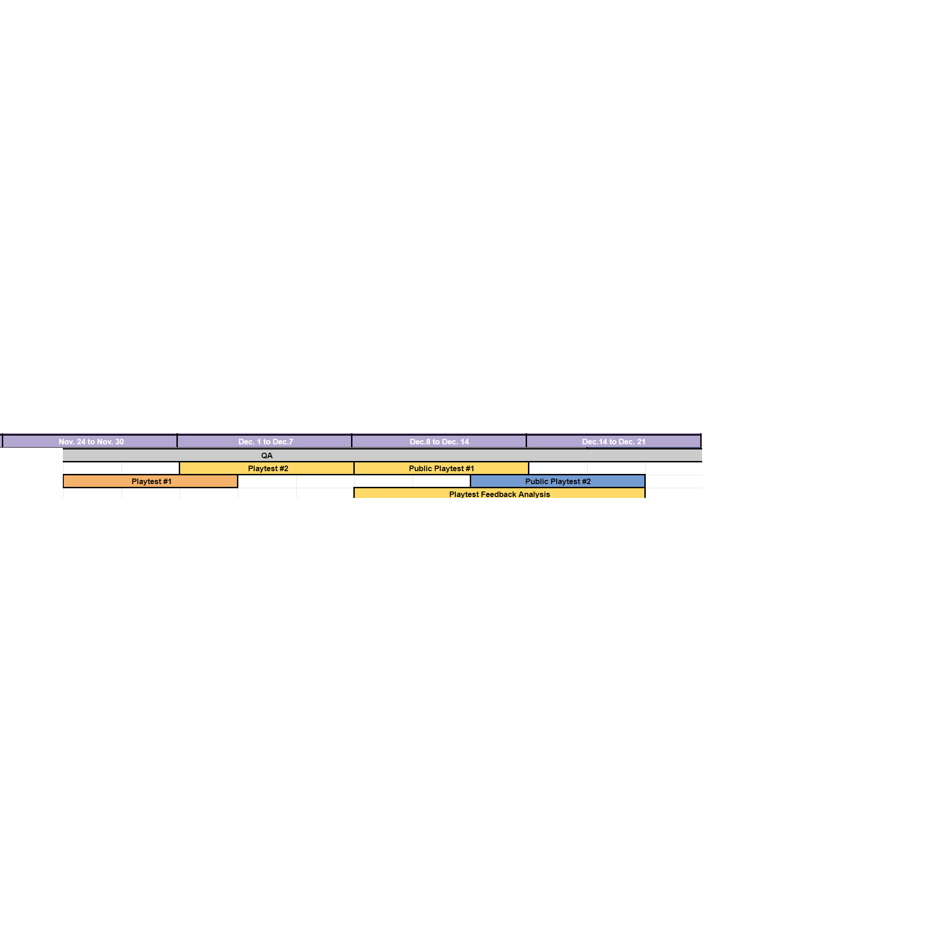

## 12.2 Bug-reports

During playtesting, the QA team must produce playtesting documentation useful for fixing bugs and tracking problems for the user experience.

### 12.2.1 QA Documentation Layout:

* + - **N° Player-testers**
    - **Average age**
    - **Playtest goals**
    - **Description**
    - **Bugs**
    - **User experience feedbacks**
    - **How to fix problems**